Table Shells - Feb. 12 Update

Adam Jauregui

February 11, 2019

Table 1: Demographics

|  |  |  |  |
| --- | --- | --- | --- |
|  | Overall | Chris Hani | King Edward |
| N | 560 | 371 | 189 |
| Age (mean (sd)) | 28.39 (5.83) | 28.82 (6.00) | 27.54 (5.39) |
| Race (%) | | | |
| Black  White  Coloured  Asian  NA | 546 (97.5)  2 (0.4)  6 (1.1)  2 (0.4)  4 (0.7) | 361 (97.3)  2 (0.5)  5 (1.3)  0 (0.0)  3 (0.8) | 185 (97.9)  0 (0.0)  1 (0.5)  2 (1.1)  1 (0.5) |
| Gravidity (mean (sd)) | 2.63 (1.11) | 2.66 (1.16) | 2.56 (1.00) |
| Parity (mean (sd)) | 1.52 (1.10) | 1.58 (1.16) | 1.41 (0.96) |
| Length of Stay (mean (sd)) | 4.78 (5.27) | 4.25 (5.11) | 5.83 (5.43) |
| Alive at Discharge (%) | | | |
| Yes  No  NA | 513 (91.6)  2 (0.4)  45 (8.0) | 334 (90.0)  0 (0.0)  37 (10.0) | 179 (94.7)  2 (1.1)  8 (4.2) |
| Gestation Age (Weeks) (mean (sd)) | 15.43 (10.38) | 15.30 (10.23) | 15.72 (10.71) |
| Gestation Age (Trimester) (%) | | | |
| <14  14-25  >25  NA | 267 (47.7)  182 (32.5)  87 (15.5)  24 (4.3) | 169 (45.6)  143 (38.5)  51 (13.7)  8 (2.2) | 98 (51.9)  39 (20.6)  36 (19.0)  16 (8.5) |
| Booking Status at Admission (%) | | | |
| Booked  Not booked  NA | 116 (20.7)  430 (76.8)  14 (2.5) | 71 (19.1)  288 (77.6)  12 (3.2) | 45 (23.8)  142 (75.1)  2 (1.1) |
| Prenatal Visits (mean (sd)) | 2.62 (1.64) | 2.09 (1.26) | 3.45 (1.83) |
| HIV Status (%) | | | |
| HIV+  HIV-  NA | 158 (28.2)  163 (29.1)  239 (42.7) | 118 (31.8)  124 (33.4)  129 (34.8) | 40 (21.2)  39 (20.6)  110 (58.2) |
| ART Use Prior to Pregnancy (%) | | | |
| Yes  No  NA | 54 (9.6)  94 (16.8)  412 (73.6) | 41 (11.1)  63 (17.0)  267 (72.0) | 13 (6.9)  31 (16.4)  145 (76.7) |

Table 2: Transfusion

|  |  |
| --- | --- |
|  | Overall |
| N | 560 |
| Bleeding this Pregnancy (%) | |
| Yes  No  NA | 354 (63.2)  163 (29.1)  43 (7.7) |
| Hemorrhage Cause (%) | |
| Abruption  Anemia  Abortion  Cervix  Fetal Death  Ectopic  Hemorrhage  Incomplete Abortion  Previa  Surgery  Threatened Abortion  NA | 5 (0.9)  1 (0.2)  19 (3.4)  2 (0.4)  4 (0.7)  114 (20.4)  3 (0.5)  237 (42.3)  4 (0.7)  14 (2.5)  28 (5.0)  129 (23.0) |
| Anemic Current Pregnancy (%) | |
| Yes  No  NA | 281 (50.2)  43 (7.7)  236 (42.1) |
| Blood Transfusion Rationale (%) | |
| Anemia  Anaesthetic  Both (Hemorrhage & Anemia)  Hemorrhage  Other  Surgical  NA | 163 (29.1)  4 (0.7)  6 (1.1)  176 (31.4)  50 (8.9)  70 (12.5)  91 (16.2) |
| Anemia Etiology (%) | |
| Iron Deficiency  Vitamin B12 Deficiency  NA | 52 (9.3)  1 (0.2)  507 (90.5) |

Table 3: Miscellaneous

|  |  |
| --- | --- |
|  | Overall |
| N | 560 |
| Previous Transfusion (%) | |
| Yes  No  NA | 38 (6.8)  506 (90.4)  16 (2.9) |
| Previous Transfusion When (%) | |
| Current Pregnancy  Previous Pregnancy  For A Non-Obstetric Reason  NA | 19 (3.4)  17 (3.0)  10 (1.8)  514 (91.8) |
| On Hematinic Therapy During Pregnancy (%) | |
| Yes  No  NA | 114 (20.4)  290 (51.8)  156 (27.9) |
| Highest Level Discussed Transfusion (%) | |
| Medical Officer  Registrar  OBGYN Consultant  Critical Care  NA | 1 (0.2)  417 (74.5)  108 (19.3)  1 (0.2)  33 (5.9) |
| Patient Transfused Where (%) | |
| Referring Institution  Current Institution  NA | 19 (3.4)  493 (88.0)  48 (8.6) |
| Where Was Patient When Transfusion Started (%) | |
| Antenatal  Labour  Postnatal  Theatre  Outpatient  Other  NA | 83 (14.8) |
| 4 (0.7) |
| 33 (5.9) |
| 143 (25.5) |
| 23 (4.1) |
| 216 (38.6) |
| 58 (10.4) |
| Pre-Transfusion Hemoglobin (mean (sd)) | 6.88 (1.89) |
| Hemoglobin Method Used (%) | |
| FBC  Blood  Gas  Point Of Care  Other  NA | 311 (55.5)  10 (1.8)  201 (35.9)  2 (0.4)  18 (3.2)  18 (3.2) |
| Were Results Obtained Before Transfusion (%) | |
| Yes  No  NA | 375 (67.0)  12 (2.1)  173 (30.9) |

## 

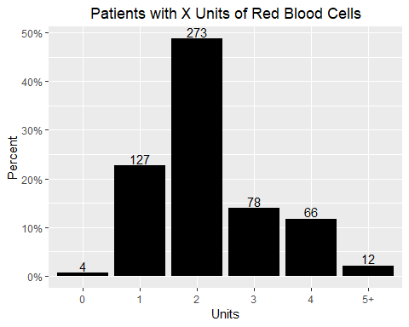

Figure 1:

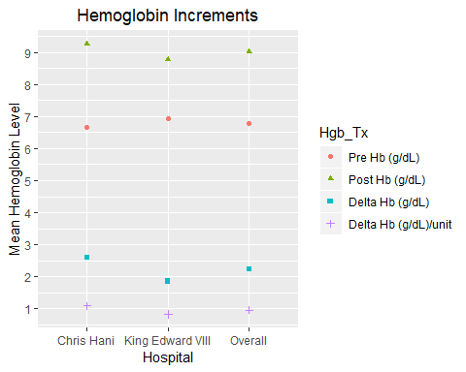

Figure 2: